1.–/5.26 pointsLarCalc11 P.1.007.
My NotesAsk Your Teacher
Sketch the graph of the equation by point plotting.
y =
−
1
5
x
+ 2

Flash Player version 10 or higher is required for this question.
You can get Flash Player free from Adobe's website.

2.–/5.26 pointsLarCalc11 P.1.009.
My NotesAsk Your Teacher
Sketch the graph of the equation by point plotting.
y = 4 − x²
x | −3 | −2 | 0 | 2 | 3
y | 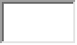

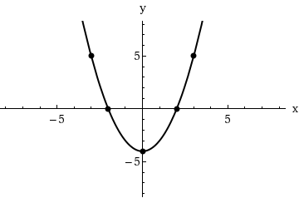 | 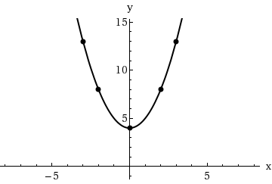
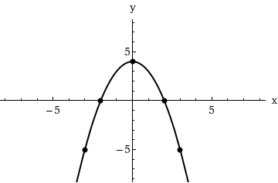 | 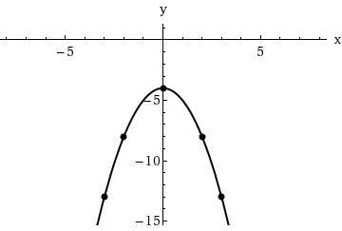

3.–/5.26 pointsLarCalc11 P.1.021.
My NotesAsk Your Teacher
Find any intercepts.
y = x² + 8x − 9
y-intercept:
  (x, y) | =
    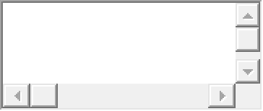
x-intercepts: |  | (smaller x-value)
  (x, y) | =
 |  | (larger x-value)
  (x, y) | =
4.–/5.26 pointsLarCalc11 P.1.023.
My NotesAsk Your Teacher
Find any intercepts.
y = x
9 − x²

y-intercept:
  (x, y) | =
x-intercepts: |  | (smallest x-value)
  (x, y) | =
  (x, y) | =
 |  | (largest x-value)
  (x, y) | =
5.–/5.26 pointsLarCalc11 P.2.013.
My NotesAsk Your Teacher
Sketch the lines through the point with the indicated slopes. Make the sketches on the same set of coordinate axes.
Point |  | Slopes
(4, 3) |  | (a) 2 | (b) -2 | (c) -3/2 | (d) Undefined
Flash Player version 10 or higher is required for this question.
You can get Flash Player free from Adobe's website.
6.–/5.26 pointsLarCalc11 P.2.020.
My NotesAsk Your Teacher
Find an equation of the line that passes through the point and has the indicated slope.
Point | Slope
(−3, −6) | m =
  8
  3

Sketch the line.
Flash Player version 10 or higher is required for this question.
You can get Flash Player free from Adobe's website.
7.–/5.26 pointsLarCalc11 P.2.024.
My NotesAsk Your Teacher
Find an equation of the line that passes through the point and has the indicated slope.
Point | Slope
(−1, 5) | m = −
  3
  2

Sketch the line.
Flash Player version 10 or higher is required for this question.
You can get Flash Player free from Adobe's website.
8.–/5.26 pointsLarCalc11 P.2.046.
My NotesAsk Your Teacher
Find an equation of the line that passes through the points.
(−2, 8), (1, 5)

Sketch the line.
Flash Player version 10 or higher is required for this question.
You can get Flash Player free from Adobe's website.
9.–/5.26 pointsLarCalc11 P.2.073.
My NotesAsk Your Teacher
Find a linear equation that expresses the relationship between the temperature in degrees Celsius C and degrees Fahrenheit F. Use the fact that water freezes at 0°C (32°F) and boils at 100°C (212°F).

Use the equation to convert 55°F to degrees Celsius. (Round your answer to one decimal place.)
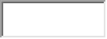 °C
10.–/5.26 pointsLarCalc11 P.3.006.
My NotesAsk Your Teacher
Evaluate the function at the given values of the independent variable. Simplify the results.
f(x) = 5x − 4
(a)
f(0)
(b)
f(−2)
(c)
f(b)

(d)
f(x + 4)

11.–/5.26 pointsLarCalc11 P.3.011.
My NotesAsk Your Teacher
Evaluate the function at the given value of the independent variable. Simplify the results.
f(x) = x³

f(x + Δx) − f(x)
Δx
(Δx ≠ 0)

12.–/5.26 pointsLarCalc11 P.3.061.
My NotesAsk Your Teacher
Given
f(x) =
x
and g(x) = x² − 4,
evaluate each expression.
(a)
f(g(2))

(b)
g(f(2))

(c)
g(f(0))

(d)
f(g(−3))

(e)
f(g(x))

(f)
g(f(x))

13.–/5.26 pointsLarCalc11 P.4.009.
My NotesAsk Your Teacher
Convert the degree measure to radian measure as a multiple of π and as a decimal rounded to three decimal places.
(a)
45°
multiple of π

decimal
(b)
150°
multiple of π

decimal
(c)
225°
multiple of π

decimal
(d)
120°
multiple of π

decimal
14.–/5.26 pointsLarCalc11 P.4.015.
My NotesAsk Your Teacher
Evaluate the six trigonometric functions of the angle θ.
(a)
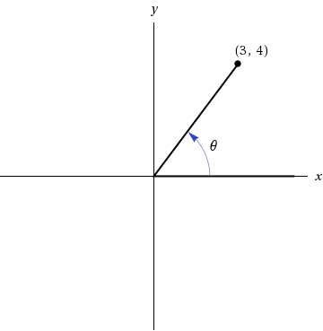
sin(θ)
=
cos(θ)
=
tan(θ)
=
cot(θ)
=
sec(θ)
=
csc(θ)
=
(b)
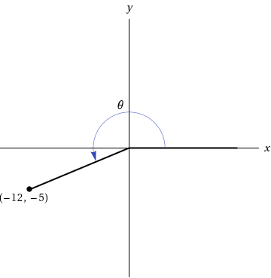
sin(θ)
=
cos(θ)
=
tan(θ)
=
cot(θ)
=
sec(θ)
=
csc(θ)
=
15.–/5.26 pointsLarCalc11 P.4.017.
My NotesAsk Your Teacher
Sketch a right triangle corresponding to the trigonometric function of the acute angle θ.
sin(θ) =
1
2
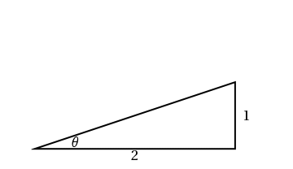

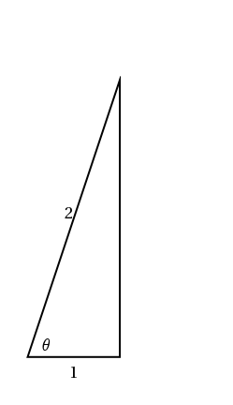

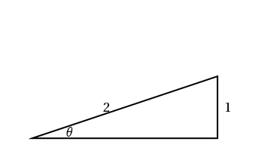

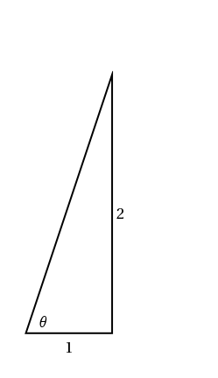
Evaluate the other five trigonometric functions of θ.
cos(θ)
=

tan(θ)
=

cot(θ)
=

sec(θ)
=

csc(θ)
=

16.–/5.26 pointsLarCalc11 P.4.021.
My NotesAsk Your Teacher
Evaluate the sine, cosine, and tangent of each angle. Do not use a calculator. (If an answer is undefined, enter UNDEFINED.)
(a)
60°
sin(60°)
=

cos(60°)
=

tan(60°)
=

(b)
120°
sin(120°)
=

cos(120°)
=

tan(120°)
=

(c)
π
4
sin

π
4

=

cos

π
4

=

tan

π
4

=

(d)
5π
4
sin

5π
4

=

cos

5π
4

=

tan

5π
4

=

17.–/5.26 pointsLarCalc11 P.4.031.
My NotesAsk Your Teacher
Find two solutions of each equation. Give your answers in radians
(0 ≤ θ ≤ 2π).
Do not use a calculator. (Enter your answers as comma-separated lists.)
(a)
cos(θ) =
3

2
θ =

(b)
cos(θ) = −
3

2
θ =

18.–/5.26 pointsLarCalc11 P.4.035.
My NotesAsk Your Teacher
Solve the equation for θ, where
0 ≤ θ ≤ 2π.
(Enter your answers as a comma-separated list.)
2 sin²(θ) = 1
θ =

19.–/5.32 pointsLarCalc11 P.4.038.
My NotesAsk Your Teacher
Solve the equation for θ, where
0 ≤ θ ≤ 2π.
(Enter your answers as a comma-separated list.)
2 cos²(θ) − cos(θ) = 1
θ =

Submit AssignmentSave Assignment Progress
HomeMy AssignmentsExtension Request

Copyright

